Design Document

Contents:

1. Web application topic
2. Target audience
3. Sitemap
4. Wireframes
5. Visual design

**Web application topic**

* Online shop for selling online redeemable keys for video games
* Registration page that requires contact info for users
* Users can have accounts that keep track of past orders

**Target audience**

* Age range of the target audience can be for people from early teens to late 40s
* Site will appeal more to men, since they’re considered more as video game enthusiasts
* Visitors will mostly come from 1st and 2nd world countries (USA, European countries, China)
* Mostly urban because they will need fast internet to download and play games, although rural visitors are possible too
* Average income of visitors can be allowance from parents, and can be any sort of income, because there are indie games that are cheap and AAA games that cost around €50
* Visitors will have studied or still studying at least on a high school level
* Marital or family status is irrelevant to how much they spend on a hobby such as video gaming
* Most common occupation for video gamers, is programmer, web developer or IT specialist, they may also still be studying
* They will probably work around 40 hours per week
* Visitors use the web regularly enough
* They use a personal computer or smartphone to access the web

|  |  |  |  |  |  |
| --- | --- | --- | --- | --- | --- |
| Name | Francis | Jeremy | Pyke | Bogdan | Amelia |
| Age | 40 | 15 | 23 | 18 | 28 |
| Location | Eindhoven | London | Zagreb | Sofia | New York |
| Occupation | Business consultant | Student | Junior software engineer | McDonald’s | Lawyer |
| Income | 24k$ | 4800$ | 15k$ | 6000$ | 60k$ |
| Gender | M | M | M | M | M |
| Web Use | 4-5 days/w | Daily | Daily | 5-6 days/w | 3-4 days/w |

**Why people would visit our site?**

* They are looking for specific pieces of software
* They want to buy it for a cheaper price
* Looking for sales and deals on software

**Francis** just saw a new game release, and wanted to buy it for a cheaper price than say the local retailor or Steam etc.

**Jeremy** has saved up enough money to finally buy the game he wants, so he uses his savings on the now discounted software.

**Pyke** wants to buy a game key for his birthday.

**Bogdan** wants to buy a PSN pre-paid card for his PS4.

**Amelia** wants to buy her son a couple of games for a cheaper price.

* People are quite familiar with what we are offering
* What our website does differently is that we offer game keys on much lower prices than say Steam, making it more affordable for people to enjoy their hobby.

**Sitemap**

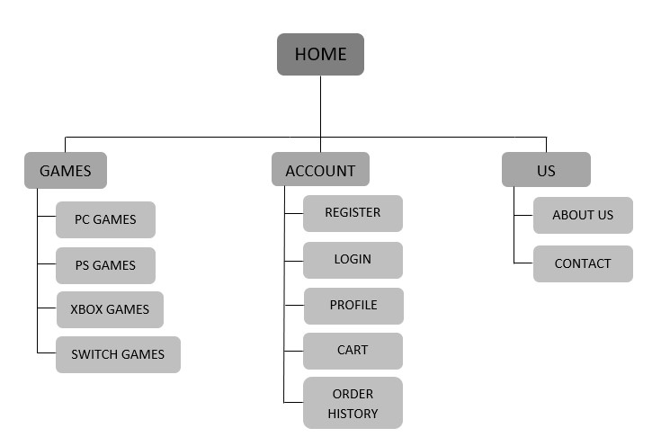

**Wireframes**

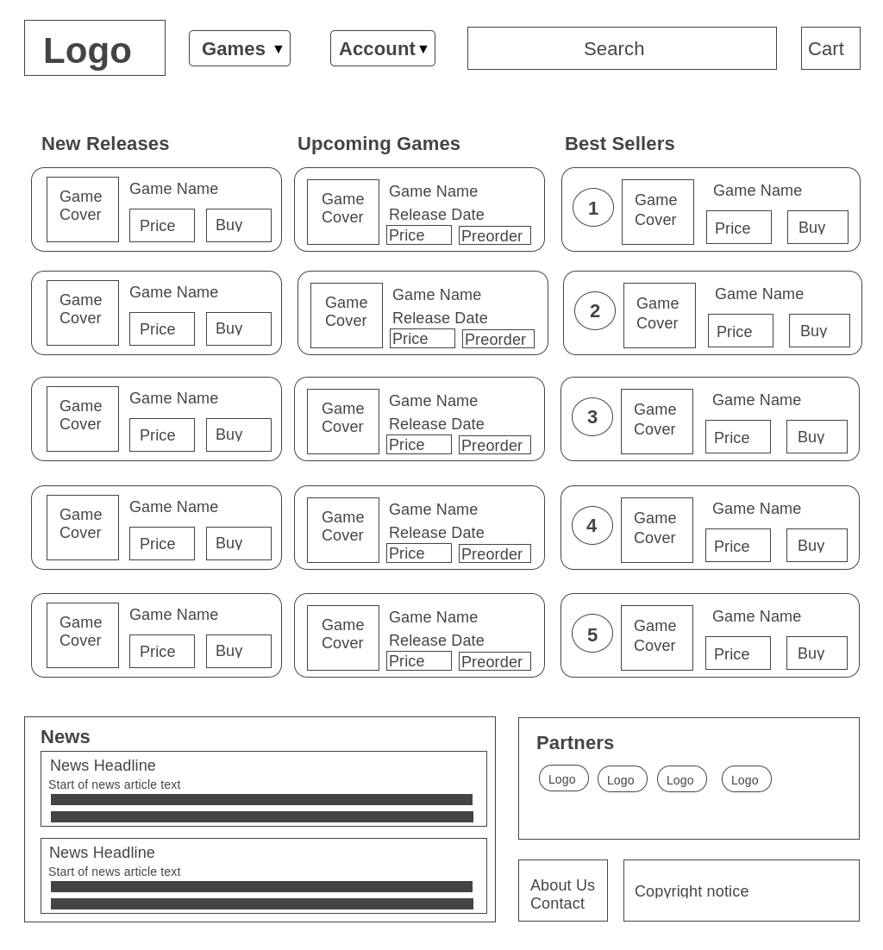Homepage:

Register:

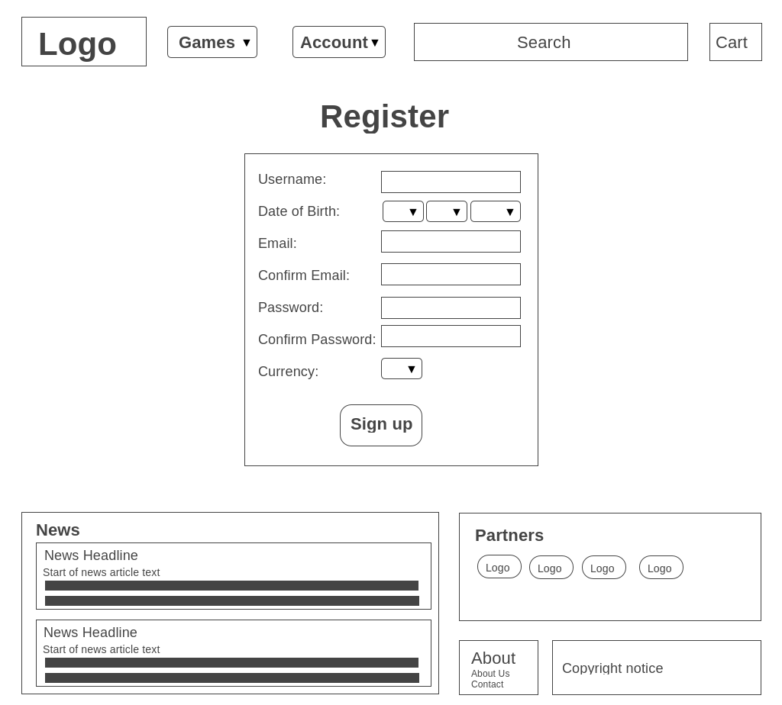

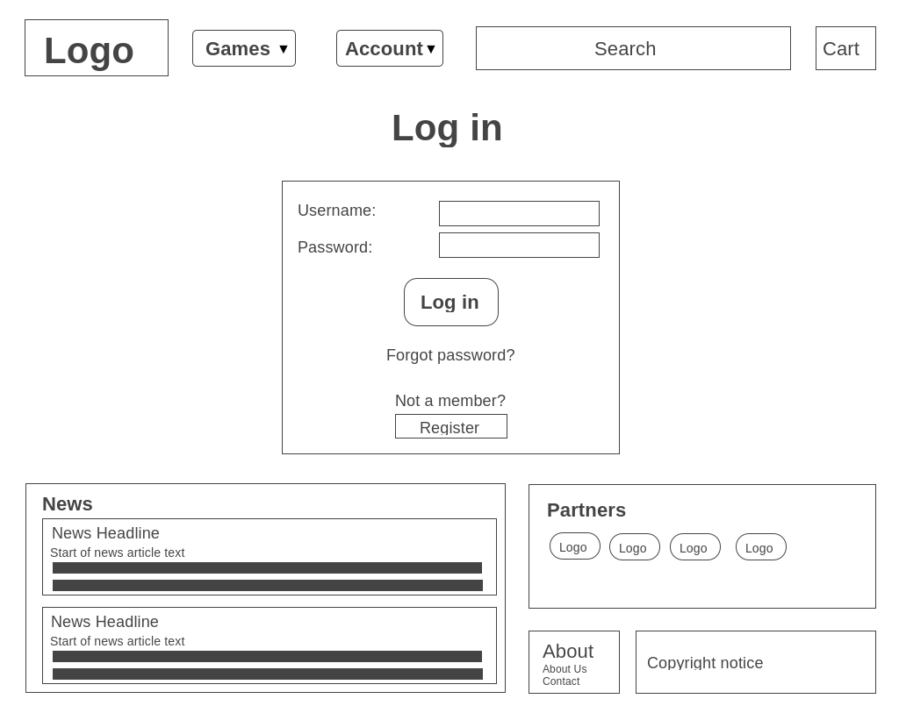Log-in:

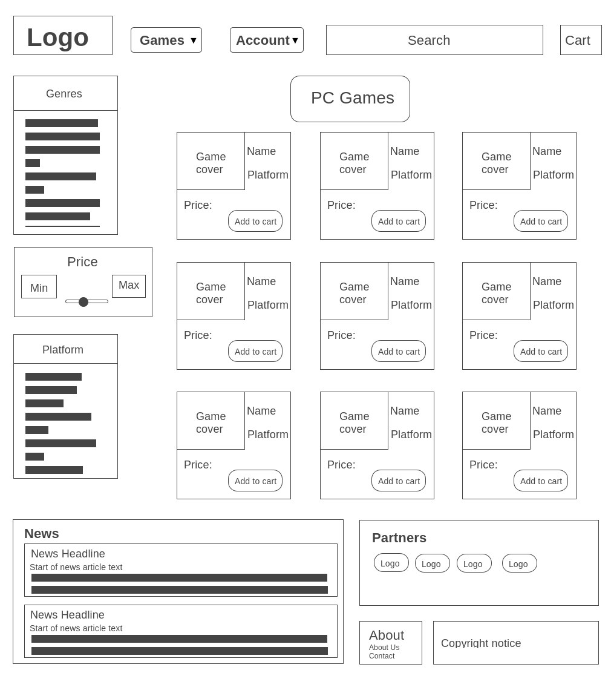PC Games:

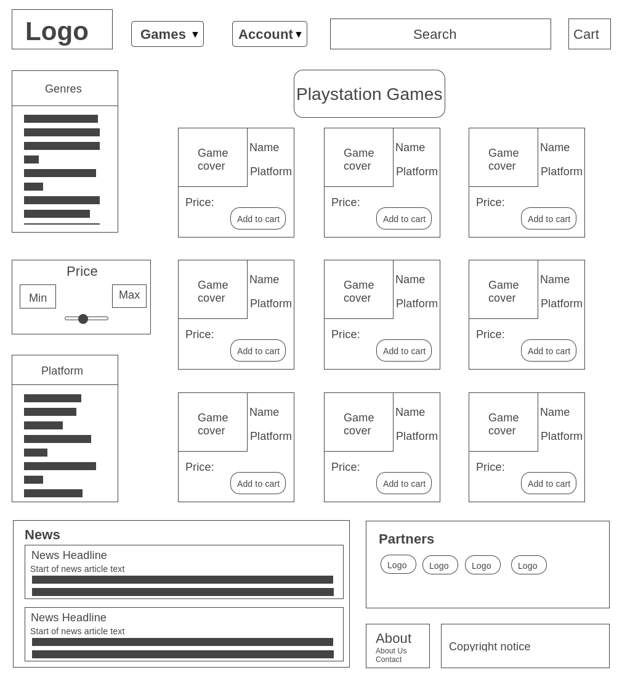PlayStation Games:

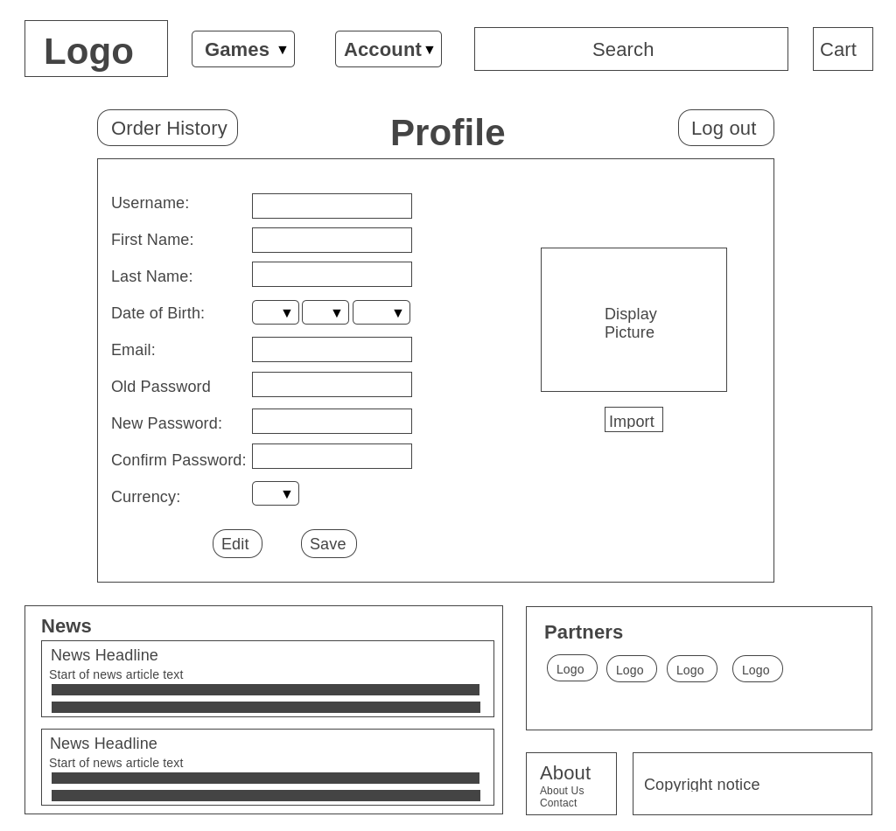Profile:

Xbox Games Page :

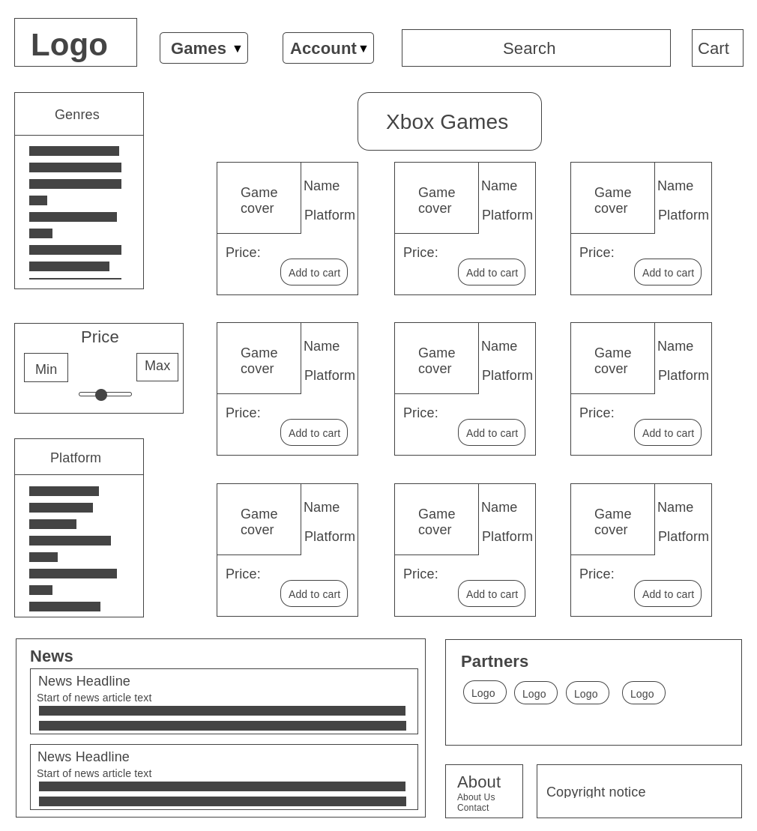

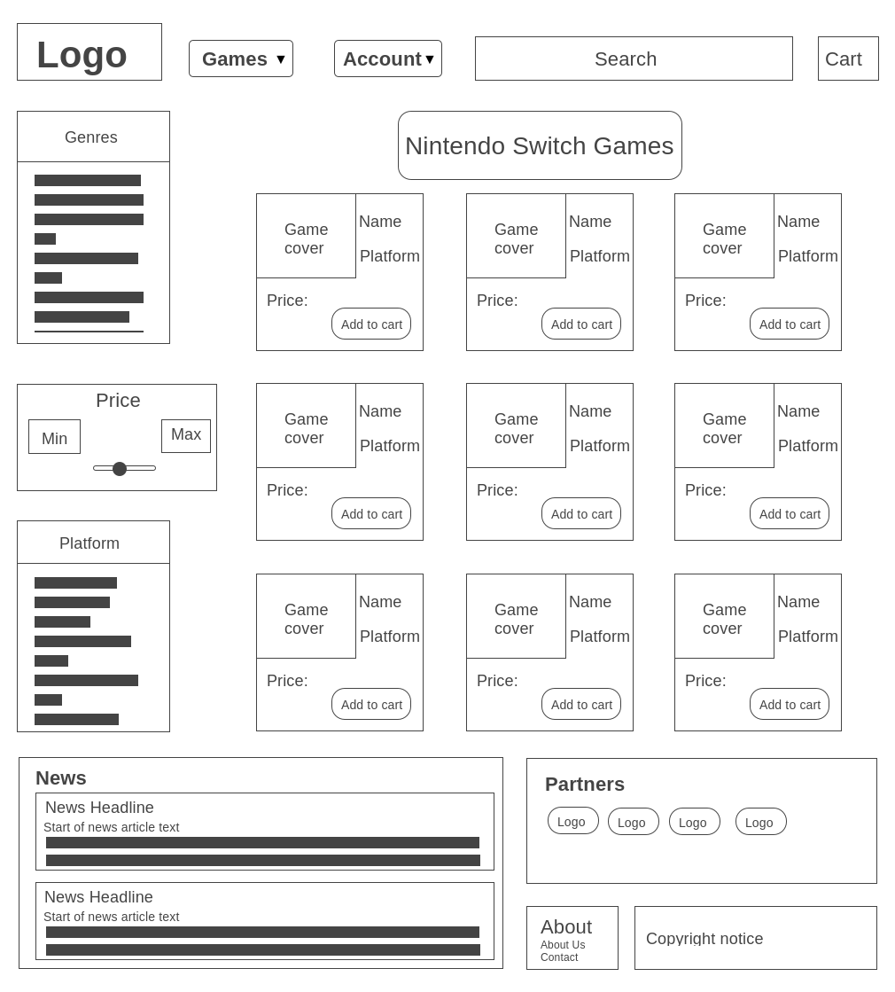Nintendo Switch Page:

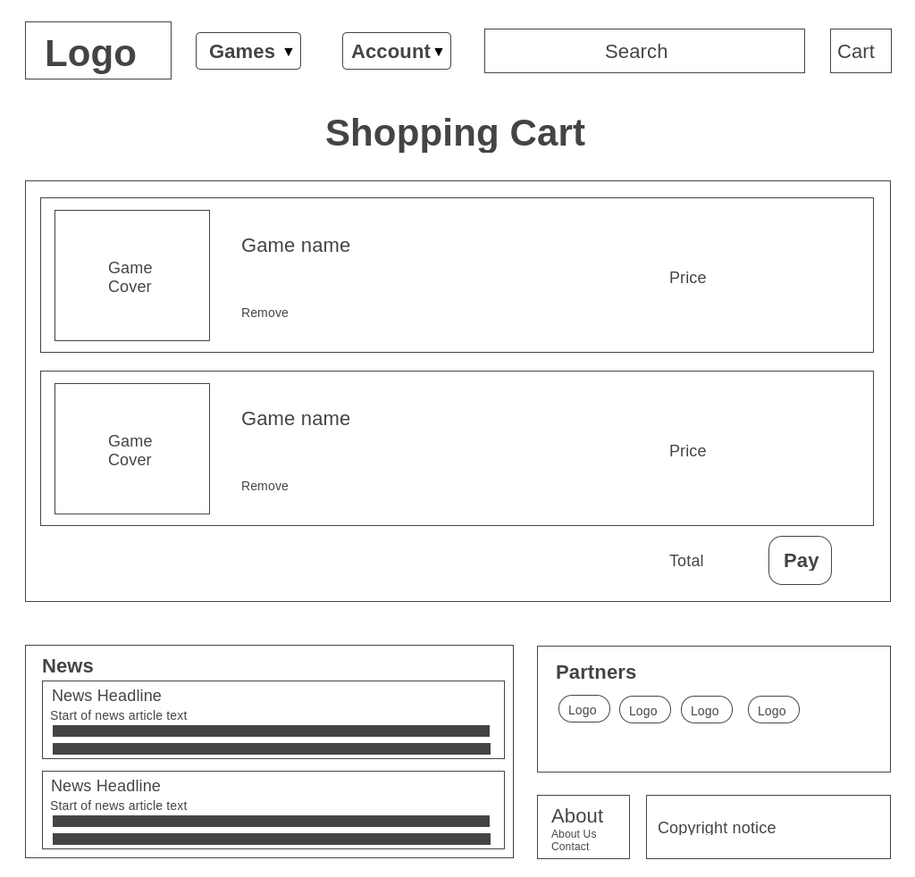Shopping Cart:

Order History:

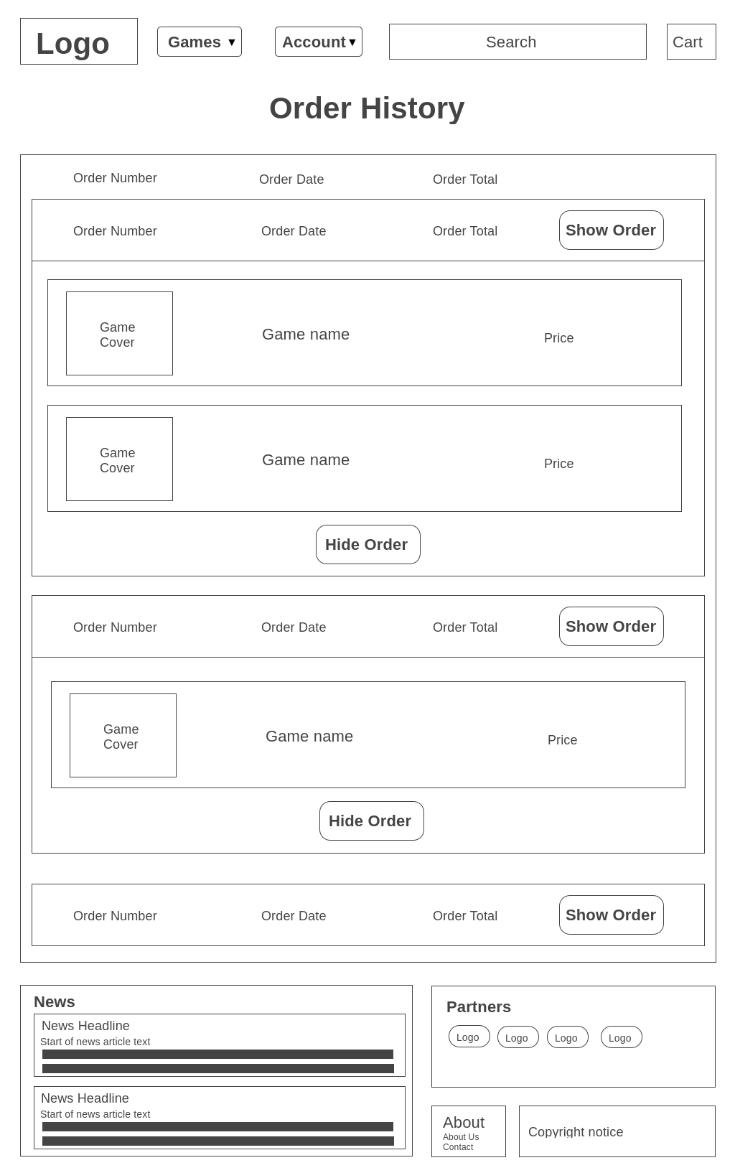

About us:

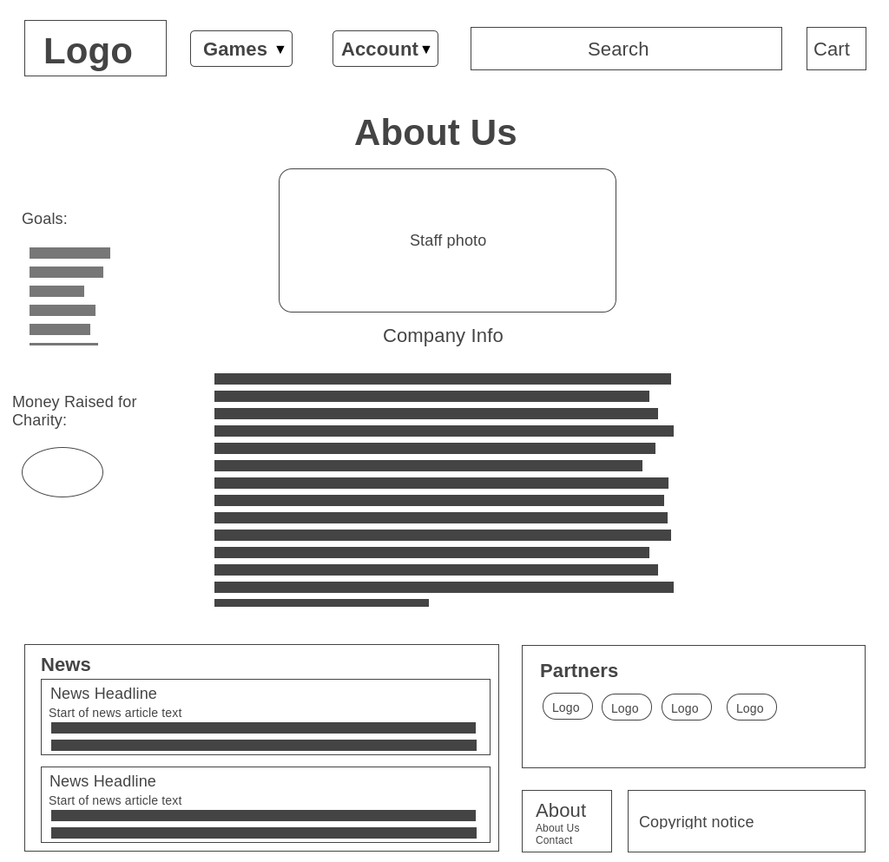

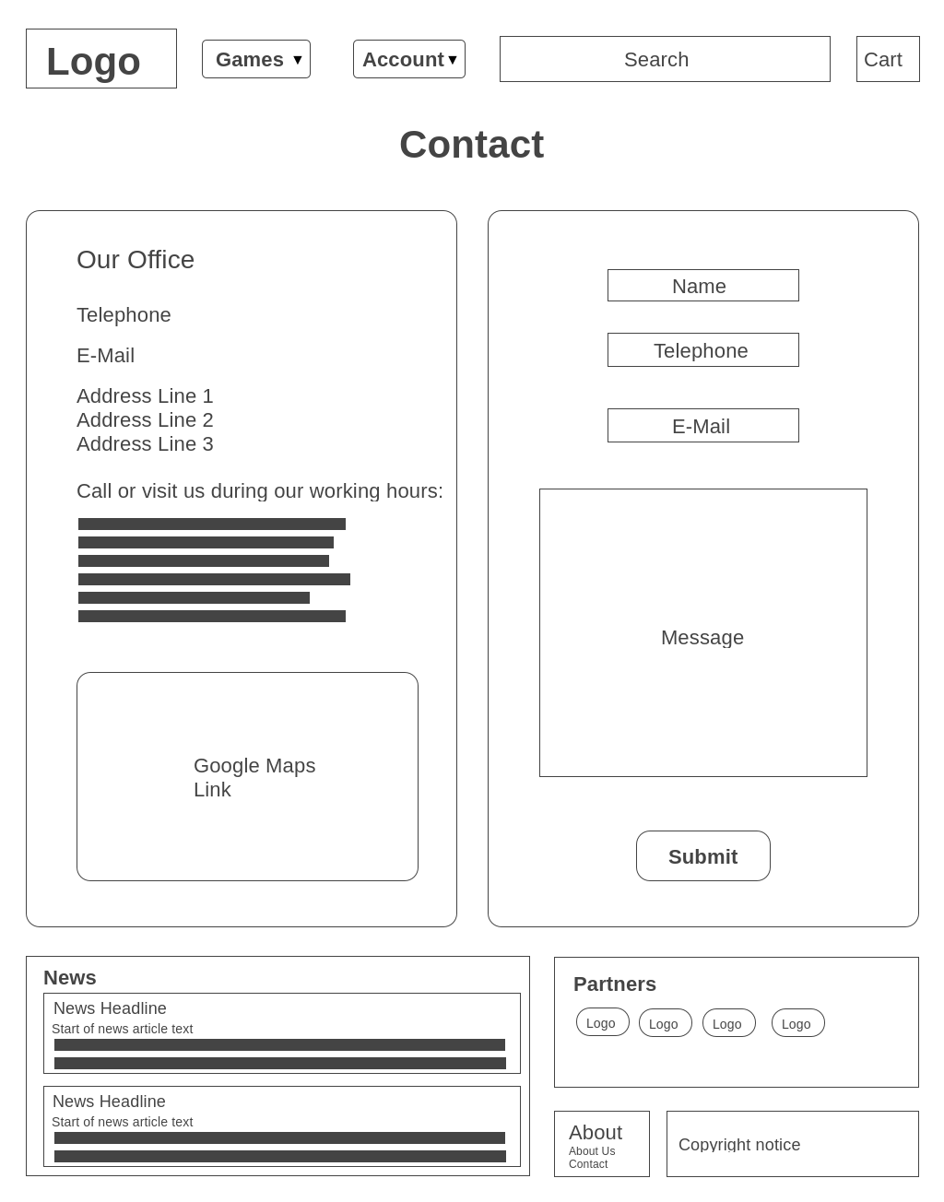Contact:

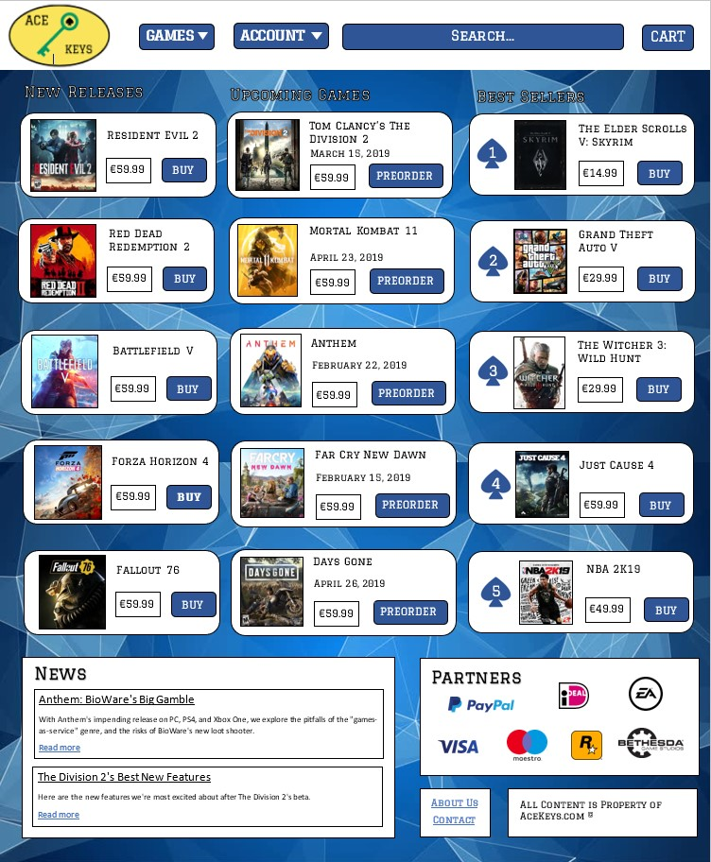**Visual Design:**